As animals bestow the gift of love upon us,
give the Gift of Life to them!
Yes, I am committed to helping Aussie Rescue SoCal save as many as we can!

I would like to make a year-end donation in the amount of $______________
I would like to make a monthly donation in the amount of $______________
My check is enclosed, made payable to Aussie Rescue SoCal, Inc.
I made my donation of $ via PayPal on your website www.AussieRescueSoCal.com
Contributions are deductible for Federal income tax purposes to the extent allowed by law.

Name________________________________________________________________________
Email________________________________________________________________________ Mailing Address________________________________________________________________
_____________________________________________________________________________ Cell Number___________________________________________________________________
Please mail this page to: Aussie Rescue SoCal, Inc. 5910 Kentland Avenue, Woodland Hills, CA 91367
Looking for another way to support Aussie Rescue SoCal?
Many employers match gifts to charities that are made by their employees.
Check with your employer to obtain the necessary form to double your donation to the animals.

ARSC 2024 Calendars are for sale! $20 per calendar, includes shipping.
You can use our PayPal: AussieRescueSoCal@gmail.com is the email address for our account,

or mail a check to: Aussie Rescue SoCal, 5910 Kentland Avenue, Woodland Hills CA 91367

PLEASE MAKE SURE YOU SAY HOW MANY YOU ARE ORDERING AND INCLUDE THE MAILING ADDRESS OF WHERE THEY ARE TO BE SENT

Thank you to all the wonderful Aussies and their families that submitted their Aussome pictures.

WE ALSO HAVE MERCH!!! PLEASE SUPPORT AUSSIE RESCUE BY BUYING SOMETHING!!

https://impressions-in-thread.printavo.com/merch/aussie-rescue

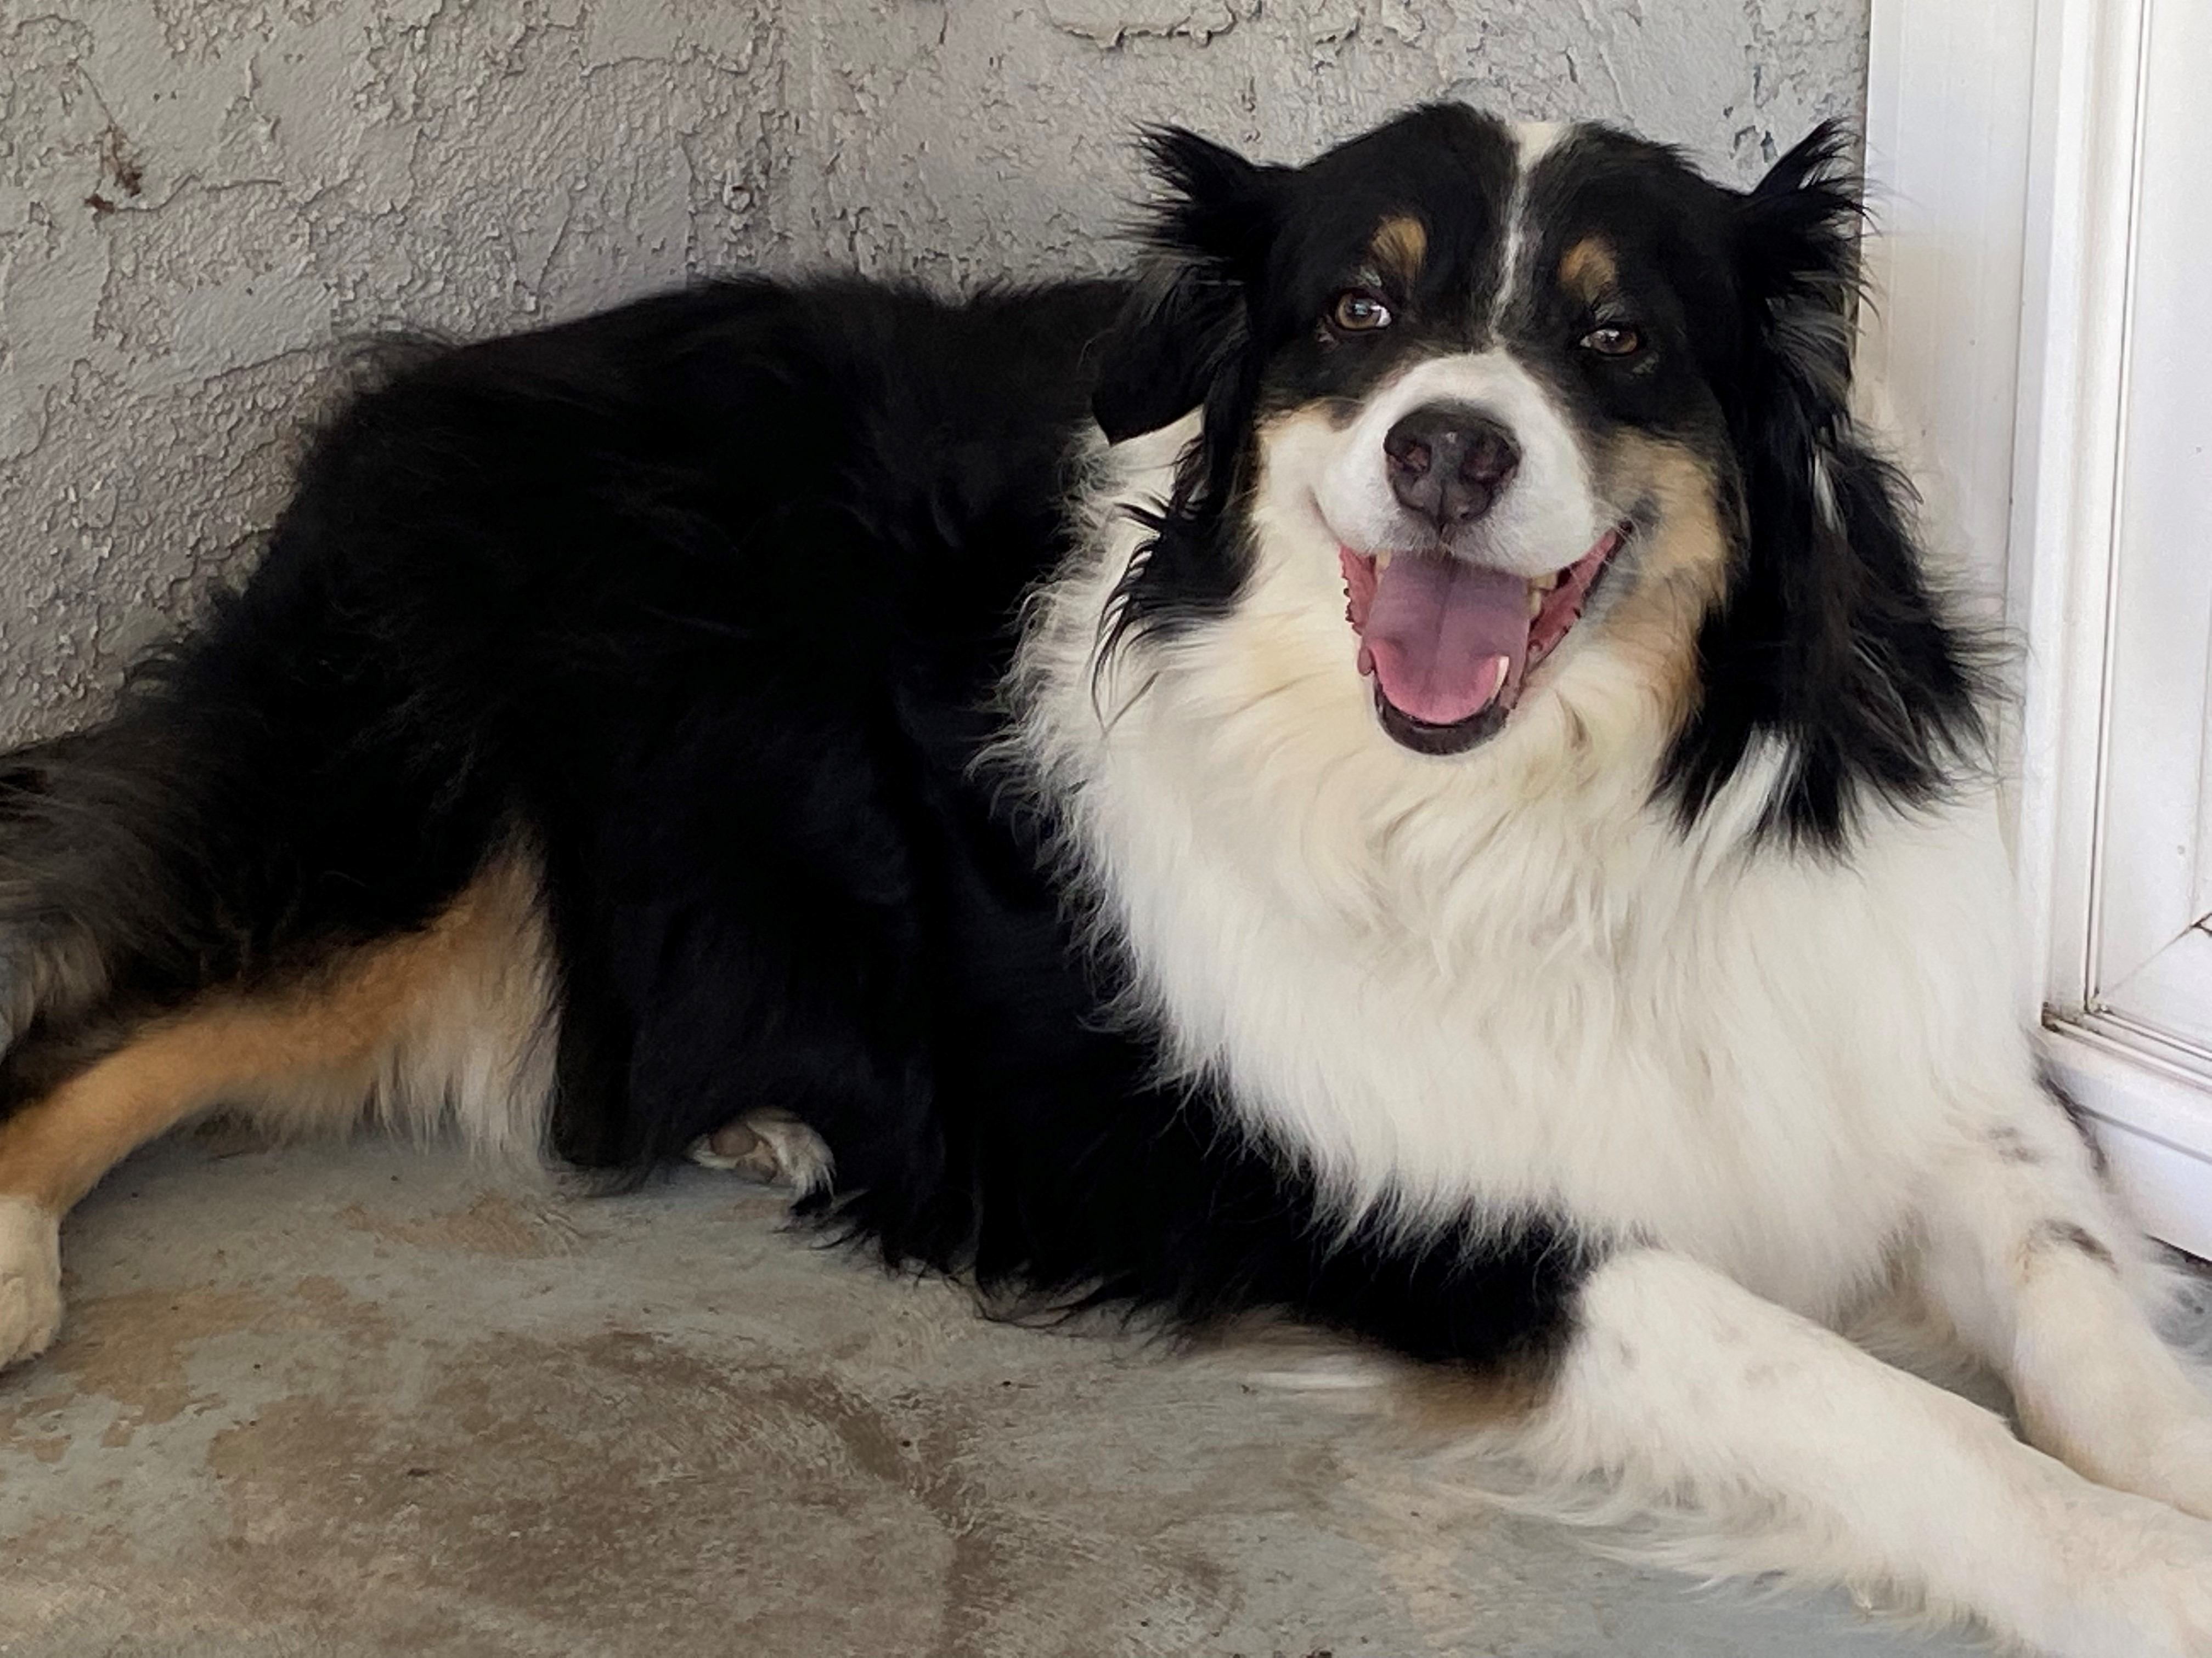

LOUIE
SAYS
THANK
YOU
SO MUCH!

